Visit <http://13.127.11.167/wondercms/loginURL>

Enter admin as the password to enter the Admin control Panel of Wonder CMS.

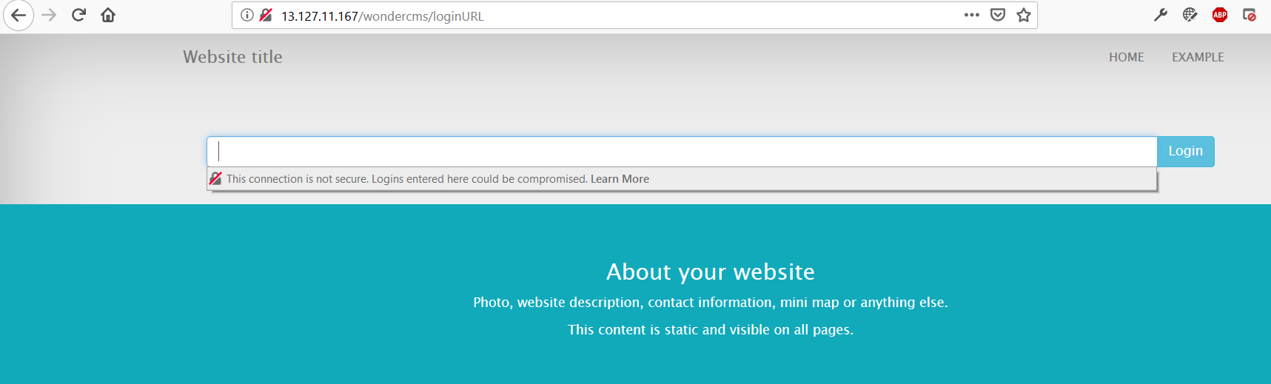

Home Page

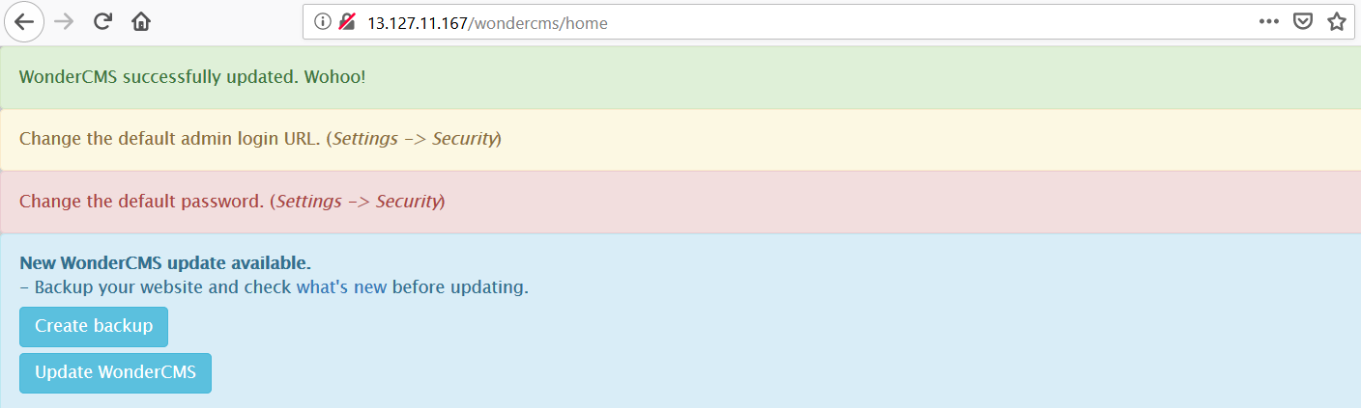

Admin Control Panel

